Instructions for searching the WLHG Archive
This Archive is a catalogue of digital documents and digital images that can be retrieved by searching with the relevant search terms.
- The Archive can be accessed by using your internet browser to type in https://wlhg.lacs.org.uk or just do a search for wlhg.lacs.org.uk
The home page of the Archive looks like below but the picture will change each time you access the Archive :-
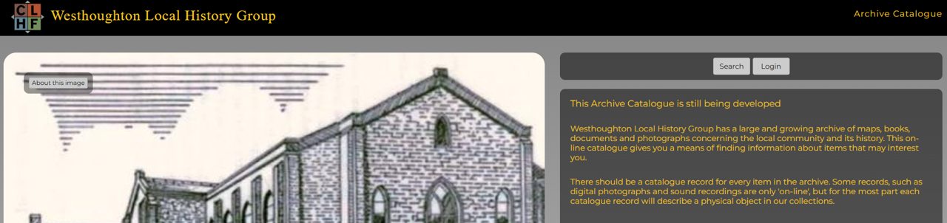
- Click on the SEARCH button on the right of the home screen. This will deliver the next screen which allows you to search the Archive by entering a word or name.
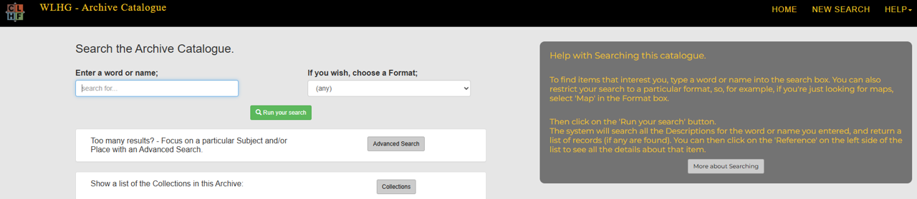
- Enter a word or name to search for eg Market Street. Then click on “Run your search”
- The result of your search will be a list of files from the Archive that relate to your search.
- Select ie click on the BLUE TEXT of a file under the heading REFERENCE eg MKTST/0017.
- The next screen will show a GREEN button named download. Click on this and a dialogue box will appear with a list of downloads to the right of your screen.
- Download the file with the relevant file name by clicking on it.
- This will produce a larger image or document that can be read.
- To do a further search, return to the initial page by clicking on NEW SEARCH button and do a new search.
At the home page there is also a box “Show a list of Collections in this Archive” together with a “Collections” button.
- Click on this “Collections” button and it will take you to a list of collections. These are groups of digital documents and digital images with a common theme eg MAPS.
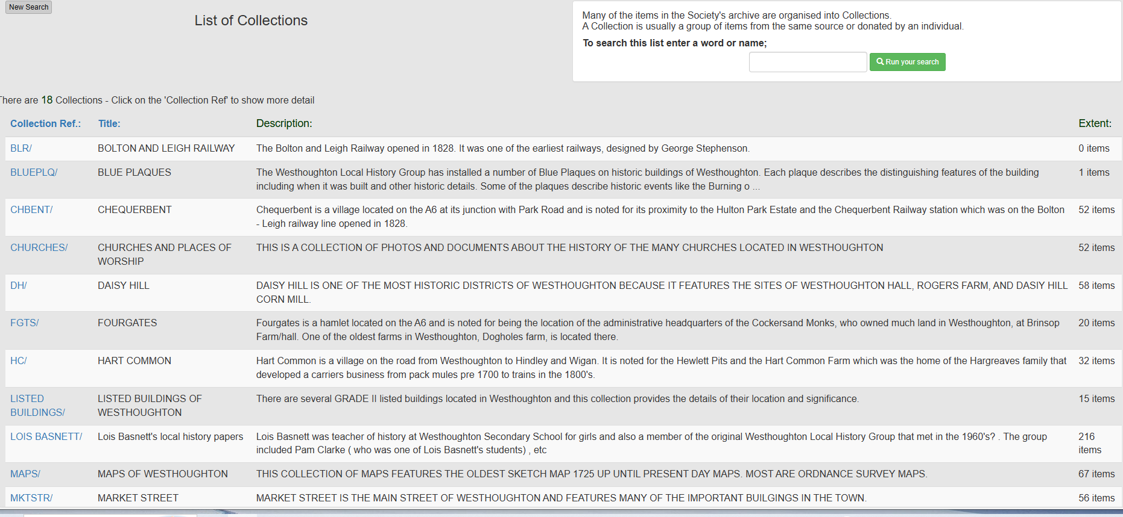
- You can search these 18 collections by clicking on a BLUE Collection Ref. This will deliver a list of digital documents and images on the same topic which can be opened as previously shown.
- You can follow instructions on the screen to return to the list of collections or start a new search.

